**Tharun Bejawada (191911509)**

**USING RAPTOR – AMSTRONG NUMBER OR NOT**

**FLOWCHART**

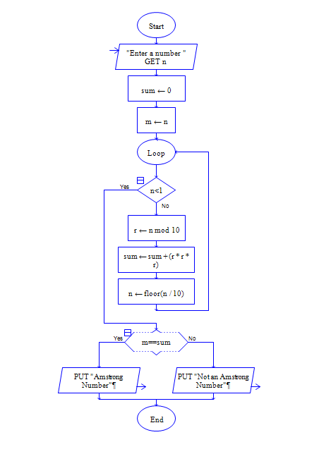

**INPUT**

371

**OUTPUT**

